Woodhouse Primary School


Pupil Premium Strategy Statement
2025 – 2026

Pupil Premium Strategy Statement

This statement details our school’s use of pupil premium funding to help secure the attainment of our disadvantaged pupils.

It outlines our pupil premium strategy, how we intend to spend the funding in this academic year and the effect that last year’s spending of pupil premium had within our school.

School overview
Detail | Data
School name | Woodhouse Primary
Number of pupils in school | 228
Proportion (%) of pupil premium eligible pupils | 7%
Academic year/years that our current pupil premium strategy plan covers (3 year plans are recommended) | 2024 - 2027
Date this statement was published | October 2025
Date on which it will be reviewed | October 2026
Statement authorised by | Kerstine Hogg Chair of Governors
Pupil premium lead | Julie O’Connor Headteacher
Governor / Trustee lead | Kerstine Hogg
Funding overview
Detail | Amount
Pupil premium funding allocation this academic year | £27,570
Recovery premium funding allocation this academic year | £0
Pupil premium funding carried forward from previous years (enter £0 if not applicable) | £0
Total budget for this academic year  If your school is an academy in a trust that pools this funding, state the amount available to your school this academic year | £27,570

Part A: Pupil premium strategy plan

Statement of intent
Our school motto is ‘Wisdom Grows From Wonder' and our overall aim is to ensure that all of our children reach their full potential in all aspects of school life and leave us armed with knowledge and skills they will need in their future. We strive for all of our children to be happy at school, to learn to love learning and to gain confidence by achieving success in many ways.
We understand that some of our educationally disadvantaged pupils face barriers to learning that have the possibility to impact on their attainment and progress. This strategy is in place to ensure that we identify where these barriers exist using accurate assessment and our knowledge of children, and to put in place effective teaching strategies and the right support to ensure these children make expected progress and are on track for achieving age-related expectations or above by the end of Year 6.
To ensure that, where necessary, we will accelerate progress and close the attainment gap between those who are educational disadvantaged and those who are not, we will:-
- provide personalised, targeted intervention for pupils, enhancing Quality First Teaching to enable every pupil deemed to be disadvantaged to make at least expected progress and be on track for achieving age-related expectations or above by the end of Year 6.
- provide personalised, targeted pastoral support for individual PP pupils to enable them to be happy, secure and fully engaged in school and supported (where appropriate) outside school.
- ensure all PP pupils have the opportunity to access learning opportunities beyond the classroom (ie. school trips and extra-curricular activities)

Challenges

This details the key challenges to achievement that we have identified among our disadvantaged pupils.
Challenge number | Detail of challenge
1 | There is a relatively small number of eligible pupils whose needs are very diverse and they are spread across the school.
2 | Adverse Childhood Experiences
3 | Instability in home life, parental separation and conflict
4 | Lack of confidence, resilience and independence
5 | Lower than average attendance for a small number of pupils

Intended outcomes
This explains the outcomes we are aiming for by the end of our current strategy plan, and how we will measure whether they have been achieved.
Intended outcome | Success criteria
Every child on-track to achieve age-related expectations by the end of year 6 in reading, writing and mathematics.  Accelerate progress and close the attainment gap between those who are educationally disadvantaged and those who are not. | Pupils are making at least expected progress if working at age-related expectations or above  Pupils are making accelerated progress in targeted areas if working below age-related expectations  Targeted pupils are in-line to achieve greater depth or higher standard.
All children are in a safe emotional state where they are able to learn. | Improvement in strengths and difficulties questionnaires following intervention such as ELSA or Place2Be.  Fewer incidents of emotional outbursts which lose learning time.
All children have good attendance at school. | All pupils have attendance at least above 95%  Improvement in attendance seen for targeted pupils
Children broaden their life experiences by engaging in activities beyond school. | All disadvantaged pupils attend trips, visits and residentials.  Access to after school clubs prioritised.  Impact on progress, engagement and outcomes

Activity in this academic year
This details how we intend to spend our pupil premium (and recovery premium funding) this academic year to address the challenges listed above.

Teaching (for example, CPD, recruitment and retention)
Budgeted cost: £5000
Activity | Evidence that supports this approach | Challenge number(s) addressed
To embed oracy across the curriculum so all pupils develop the ability to speak, listen, and communicate effectively | A focus on the evidence shows that Oral language interventions can have a positive impact at all phases of education, but the impact is highest in the early years (+7 months), and higher in primary schools (+6 months) than in secondary (+5 months).  High impact for very low cost based on extensive evidence EEF Toolkit | 1, 2, 4, 5,
As part of the leadership development in the SDP continue to deveop the use of Peer Tutoring in school including a range of approaches in which learners work in pairs or small groups to provide each other with explicit teaching support, with a focus on cross-age tutoring, in which an older learner takes the tutoring role and is paired with a younger tutee | Peer tutoring, on average, has a positive impact on both tutors and tutees and may be a cost-effective approach to delivering one to one or small group tuition in a school.  Peer tutoring may be particularly effective for low-attaining pupils in the role of tutee. This approach shows promise for supporting these pupils to catch up with their peers.  High impact for very low cost based on extensive evidence EEF Toolkit | 1, 2, 4, 5

Targeted academic support (for example, tutoring, one-to-one support structured interventions)
Budgeted cost: £18000
Activity | Evidence that supports this approach | Challenge number(s) addressed
Individual Maths Tutoring through Third Space Learning  Analysis of diagnostic assessment to identify gaps in knowledge and understanding. Specialist support then timetabled: in class, pre-teach or focused specialist support, outside the classroom either 1:1 or small group. Timetables reviewed termly following review of pupil progress.  Reading Plus – online programme  IDL Personalised multi-sensory intervention | EEF One to One Tuition High Impact +5 month progress | 1, 2, 4, 5 ,
EEF Improving literacy in Key Stage 2
Recommendation 6
Target teaching and support by accurately assessing pupil needs
Small group tuition is most likely to be effective if it is targeted at pupils’ specific needs. Diagnostic
assessment can be used to assess the best way to target support EEF May 2022 +4 months progress.

Wider strategies (for example, related to attendance, behaviour, wellbeing)
Budgeted cost: £4570
Activity | Evidence that supports this approach | Challenge number(s) addressed
Support from Emotional Literacy support assistant (ELSA) | Good mental health is important for helping children and young people to develop and thrive.  ‘Promoting children and young  people’s mental health and wellbeing’ 2021 | 1, 2, 3, 4, 5
Improve attendance for targeted pupils.  Implement rigorous attendance tracking and intervention.  Hold attendance meeting where necessary and monitor impact. | Wider strategies relate to the most significant non-academic barriers to success including attendance.  There is some evidence of promise for parental communication and engagement approaches, and responsive interventions that meet the individual needs of the pupils and target the individual causes of low attendance.”  The interventions that show promise take a holistic approach in understanding pupils and their specific need, and address the specific barriers to attendance that have been identified.  Attendance Interventions Rapid  Evidence Assessment (EEF, 2022) | 3, 4, 5,
We will fund, where appropriate and after discussion with parents and outside agencies, activities from the following:  • Extra-curricular Clubs  • Additional lessons e.g. music, drama  • School Trips  • Residential trips | We recognise the impact that full access to school life has for children and understand the importance of supporting and funding this access where appropriate. | 1, 2, 3, 4, 5
Total budgeted cost: £27,570

Part B: Review of outcomes in the previous academic year

Pupil premium strategy outcomes
This details the impact that our pupil premium activity had on pupils in the 2023 to 2024 academic year.
Activity | Impact
To ensure that children know and remember more by further developing ways to embed and revisit prior learning. Teacher CPD | 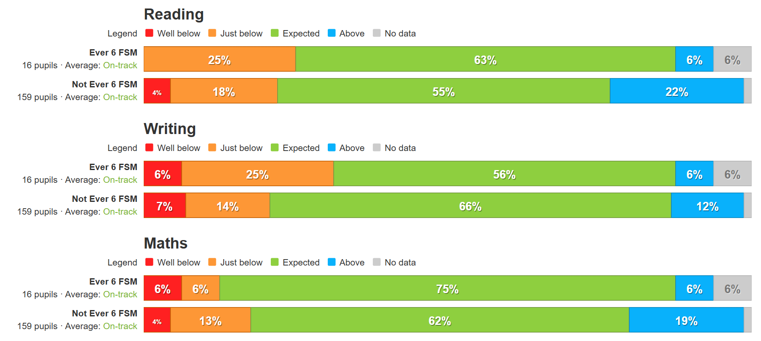
Continue to raise standards in school by reviewing our approach to guided reading, ensuring that our proportion of children achieving greater depth in reading is at least in line with school prior performance and national averages. Teacher CPD and resources | The percentage of pupils achieving greater depth in reading rose from 23% in 2024 to 43% in 2025.  In Year 6 there was only 1 disadvantaged pupil, who achieved the expected level in all subjects.

Activity | Impact
Individual Maths Tutoring through Third Space Learning  Analysis of half termly / termly assessments and on-going formative assessment to identify gaps in knowledge / understanding. Specialist support then timetabled:  Focused specialist support, outside the classroom either 1:1 or small group. Timetables reviewed termly following review of pupil progress.  (Reading Plus) | In Year 6 there was only 1 disadvantaged pupil, who achieved the expected level in all subjects.

Activity
Support from Emotional Literacy support assistant (ELSA)  Improve attendance for targeted pupils.  Implement rigorous attendance tracking and intervention.  We will fund, where appropriate and after discussion with parents and outside agencies, activities from the following:  • Extra-curricular Clubs  • Additional lessons e.g. music, drama  • School Trips  • Residential trips  • Residential trips | We increased our ELSA offer by training a new Early Year ELSA.  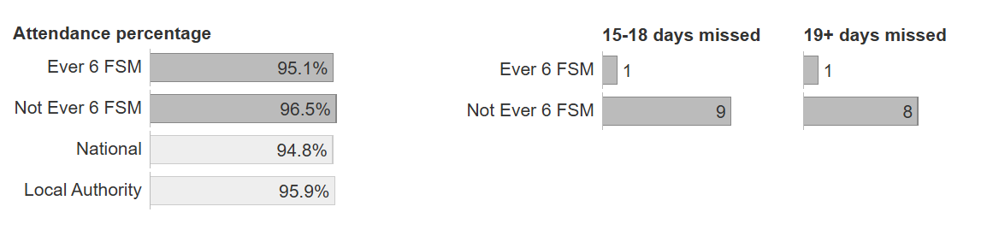  Attendance for disadvantaged pupils improved from 94.5% to 95.1%  Funds were used to support pupil access to wider curriculum provision such as residentials and visits.  Priority access was given to, and funding for, after-school clubs.  Children were provided with school uniform where appropriate.  School funded additional music lessons.

Externally provided programmes
Please include the names of any non-DfE programmes that you purchased in the previous academic year. This will help the Department for Education identify which ones are popular in England
Programme | Provider
Mathematics Tuition | Third Space Learning
Reading Programme | Reading Plus
IDL | Personalised reading, writing and maths programme

